Pokhara University

Level: Bachelor | Semester – Fall | Year : 2010
Programme: BE |  | Full Marks : 100
 |  | Pass Marks: 45
Course: Electromagnetic Fields and Waves |  | Time : 3hrs.

Candidates are required to give their answers in their own words as far as practicable.
The figures in the margin indicate full marks.

Attempt all the questions.

1. | - Derive the expression of electric field intensity for infinite line charge.  - State Gauss law. Derive an expression for electric field due to an infinite coaxial cable with air dielectric using the law. | 8  7
2. | - Surface charge densities of 200, -50 and 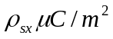 are located at r = 3.5 and 7 cm respectively. Find D at  - r = 2cm and r = 6 cm  - Find 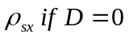at r=7.32  - Potential is given by 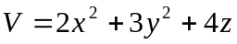in free space. At a point P (2, -1, 3), calculate:  Potential at point P  Electric field intensity E at point  Flux density at point P  Volume charge density 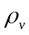at point P | 8  7
3. | - State and prove uniqueness theorem.  - Given the magnetic flux density 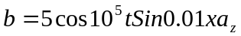 mT. Find:  - The magnetic flux passing through the surface z=0, 0<x<20m, 0<y<3 m at 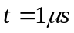  - The value of the closed line integral of E around the perimeter of the surface specified above, at 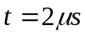. | 7  8
4. | - Find the current density associated with the field  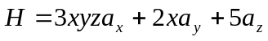at point P(4,3,2)  - Define CURL with its physical significance. Also distinguish between Vector and Scalar magnetic potential.  - Show that the scalar magnetic potential is multivulued function of position | 5  5  5
5. | - Define Poynting vector. Derive the relation for power flow associated with an electromagnetic wave.  - What is Skin effect? Find the expression for skin depth. | 7  8
6. | - Define propagation constant and characteristic impedance. Write their general expression in terms of line parameters R, L,G and C for sinusoidal excitation.  - A single stub tuner is to match the lossless line of 400ohm to a load of 800-j400ohm. The frequency is 3Ghz. Find the position and length of the short circuited stub from the load end(using Smith Chart) | 7  8
7. | Write short notes on (Any Two)  - Magnetic circuit  - Retarded potential  - Laplace's and Poisson's equation | 5x2

